**Topics: Loop, Range, List, String, Dictionary**

1. Sum the following series:
   1. 1 + 3 + 5 + 7 + …. Up to **n-th** term = ?
   2. 2 + 4 + 6 + ….. + 2n = ?
   3. 2 + 4 + 8 + ….. + $n^{2}$ = ?
   4. log(1) + log(2) + log(3) + …. + log(n) = ?
2. You have a group of 3 students. Each student has a name, ID and dept stored in a dictionary. And all 3 students are stored in a “students” dictionary. Now use a loop to iterate through the “students” dictionary and print only the “name” of all the students.
3. You have a list of students. Each student’s information is stored using a dictionary.

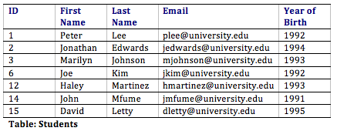

Now write a python program to search a student by his/her ID. Use a loop and conditional so that this can also work on a big list of students.